Pretty Spool
A Fused Art Quilt copyright Laura Wasilowski 2020
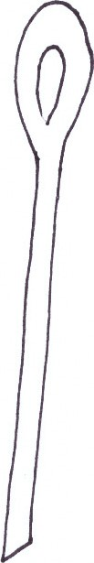
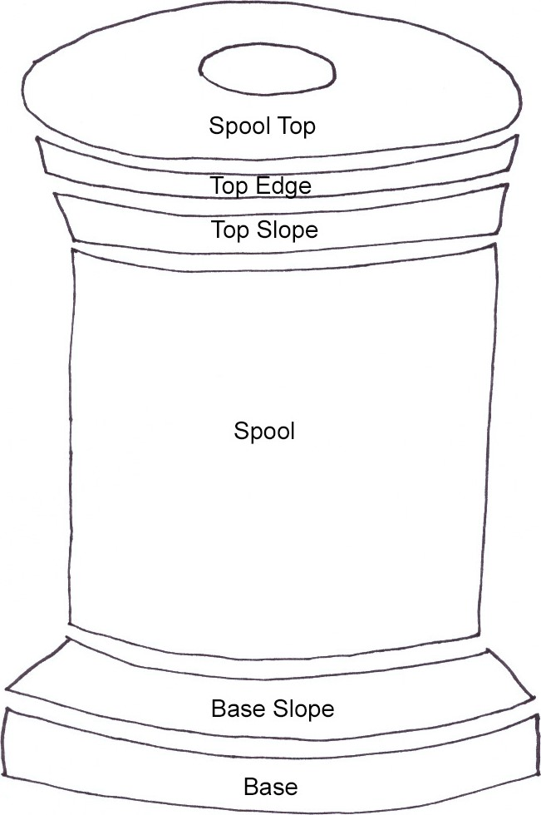 Needle

