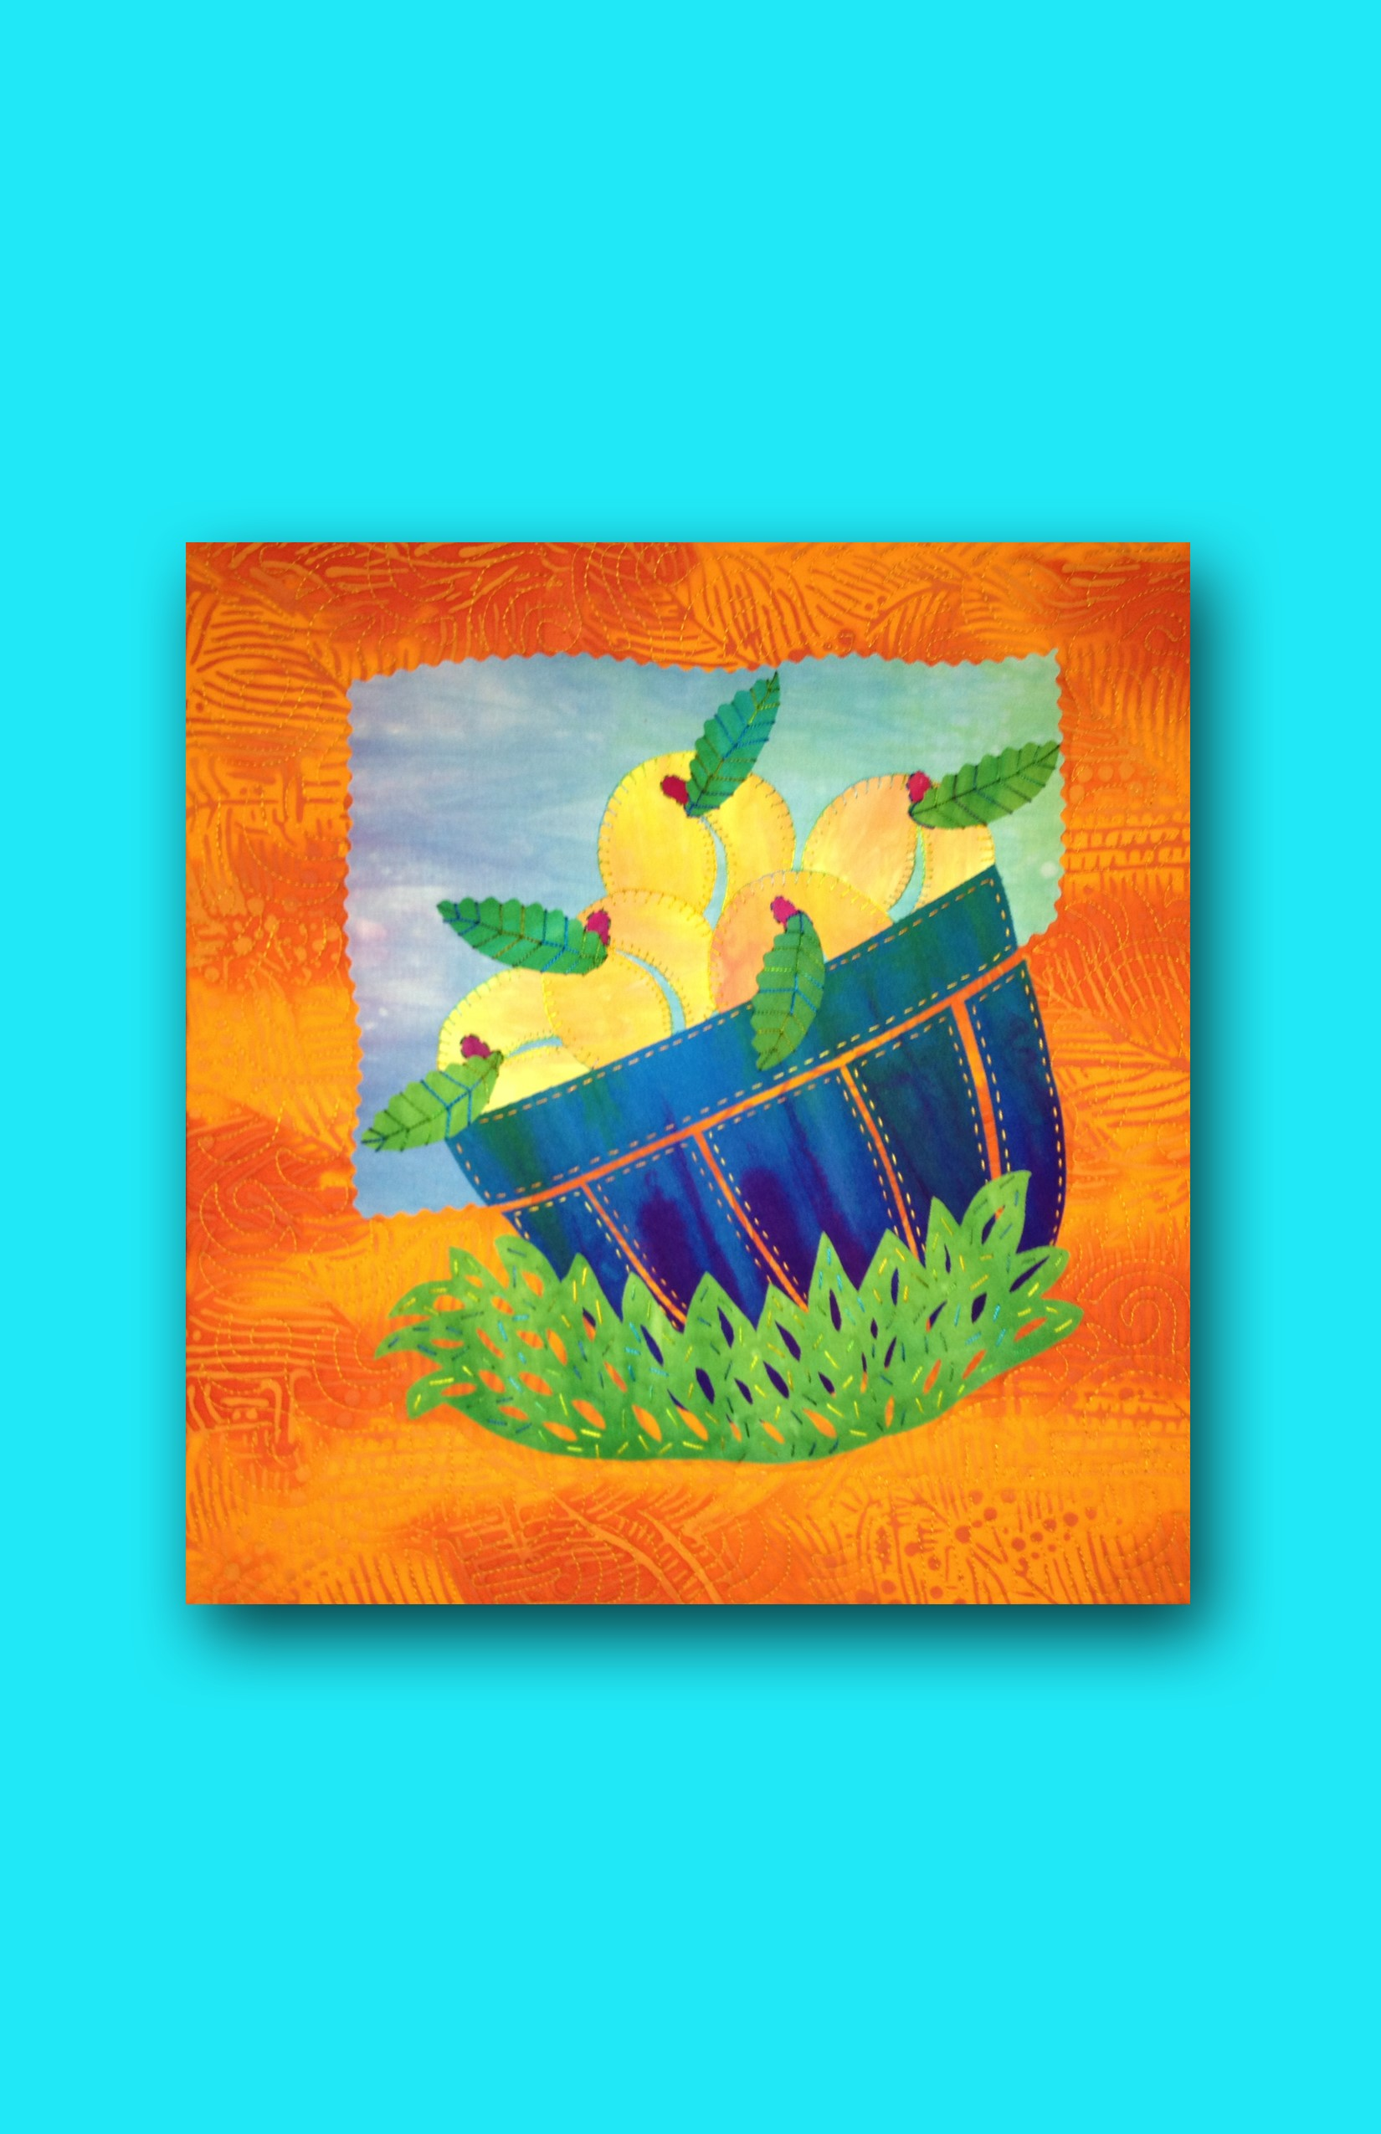

Penelope’s Peaches
A Fused Art Quilt, Finished Size about 13" x 13"
© Laura Wasilowski 2019

Materials and Tools
15" x 15" orange batik for background  9" x 8" light green to light purple for sky  9" x 6" blue to purple for basket  9" x 6" light yellow to light orange for peaches  2" x 2" red violet for stems  9" x 7" green for grass and leaves  1 ½ yards of fusible web (Wonder Under #805 recommended)  Parchment paper (optional)  13" x 13" batting (Hobbs Heirloom Premium  80/20 Batting recommended) | 13" x 13" Timtex or other brand stiff interfacing  13" x 13" backing fabric  Parchment or baking paper (optional)  Black Sharpie Fine Point marker or lead pencil  Rotary cutter, mat, and ruler  Decorative rotary cutter blade (pinking blade recommended)  Size 8 or 12 embroidery thread  Size 4 or 5 embroidery needle  Machine quilting thread

Preparation
- This quilt measures about 13" x 13" upon completion and is hand stitched and machine quilted.
- Assemble all the materials and tools listed.
- Fuse all the fabrics following the manufacturer’s directions.
- After the fabric cools, remove all the paper except that on the background fabric.
- Save this Release Paper. It is needed for the construction of this quilt.

Directions
- Place the Release Paper or parchment paper on the sky pattern. Trace the pattern with the Sharpie marker or a lead pencil. (Please note that any writing or numbers written on the release paper will also transfer to the fabric.)
- Place the marker side of the release paper onto the glue or fused side of the sky fabric. Iron or fuse the paper in place for 5-7 seconds with a hot iron.
- After the fabric cools, remove the release paper from the fabric. The ink from the tracing will transfer to the glue.
- Cut out the sky shape just inside the black line with scissors.
- Trim 1/4" from each edge of the sky using the pinking blade in the rotary cutter.
- Center the sky on the background fabric with the angled edge facing down. The top edge should be about 2 ½" in from the top edge of the background fabric and 3" in from each of the sides. Fuse-tack into place.
- Repeat Steps 1 – 4 to make the 6 basket parts and 5 peaches.
- Place the lower edge of the basket rim onto the lower edge of the sky following the angle of the sky. The lower edge of the rim should just cover the lower edge of the sky to conceal that edge.
- Slip 4 peaches just under the top rim of the basket. The narrow cut out on the peach should face down. Some peaches will overlap other peaches. Slip the fifth peach under the top of 2 peaches to stack the peaches. (Use the photo as a guide.) Fuse-tack the peaches and basket rim into place.
- Cut the stem fabric on the bias (from corner to corner) to form 2 triangles. Cut 2 bias strips about 1/4" wide from the long bias side of one of the triangles.
- Cut 5 stems from the stem fabric strips measuring about 3/4" long. Round each end of each stem with scissors.
- Place a stem on each peach on the tip of the narrow cut out on the peaches. Fuse-tack into place.
- Arrange the remaining basket parts in order beneath the basket rim. Space the shapes so there is a 1/8" to 1/4" gap of the background fabric showing between each basket shape. Fuse-tack into place.
- Repeat Steps 1 – 4 to make the 5 leaves and the grass.
- Trim 1/4" from one edge of each leaf using the pinking blade in the rotary cutter.
- Place the tip of a leaf on each stem. Fuse-tack into place.
- Fold and snip out thin ovals measuring about 3/4" long from the grass fabric to make the blades of grass.
- Place the grass horizontally across the bottom edge of the basket. Fuse-tack into place.

Finishing with a Wrapped Binding
- Remove the release paper from the background fabric. Center the non-scrim side of the batting onto the back of the quilt top. (Please note that if the background fabric is applied to the scrim side of the batting and fused into place, the quilt may appear rippled.) There should be about 1" of fabric hanging over the edge of the batting on each side.
- Flip the batting and quilt top over holding everything in place and place it back onto the release paper.
- Place a dry cloth on the quilt top and steam set the top to the batting for about 10 seconds in each spot.
- After it cools, remove it from the release paper.
- Add hand embroidery stitches with the size 8 or 12 pearl cotton thread and an embroidery needle.
- Place the quilt top right-side down on the ironing surface. Match the Timtex shape to the batting and put in place.
- At a corner, fold the quilt top fabric onto the Timtex to form a right angle. Leave a little ease at the tip of the corner to get a sharp point. Fuse-tack the fabric just at the corner.
- Repeat Step 7 at each corner of the quilt.
- At a corner, fold one side of the quilt top fabric onto the Timtex. Slowly pull, wrap, and fuse-tack the quilt top to the back following the edge of the Timtex. Stop about mid-way down the edge.
- At that same corner, fold the other side of the quilt top fabric onto the Timtex making a sharp point at the corner. Slowly pull, wrap, and fuse-tack the quilt top to the back following the edge of the Timtex. Stop about mid-way down the edge.
- Repeat Steps 9 – 10 around the perimeter of the quilt.
- Trim about 1/2" from the perimeter of the backing fabric. Use a decorative blade in the rotary cutter if available.
- Center the backing fabric, glue side down, onto the back of the quilt. Fuse-tack into place.
- Steam set the back of the quilt.
- Machine stitch the quilt.
- Add a hanging loop to the back of the quilt.

For more information about fusing, read Laura’s book Fanciful Stitches, Colorful Quilts published by C&T Publishing.
For more about the fabrics used in this pattern visit:
www.artfabrik.com laura@artfabrik.com
324 Vincent Place Elgin, IL 60123

Penelope’s Peaches
Laura Wasilowski
Copyright 2013
Peaches
(
cut
5)
Leaves
(
cut
5)
Sky

top
<-------
Penelope’s Peaches
Laura Wasilowski
Copyright 2013
Grass
Basket
Rim
top ---->
Basket #1
Basket #2
Basket #3
Basket #4
Basket #5

