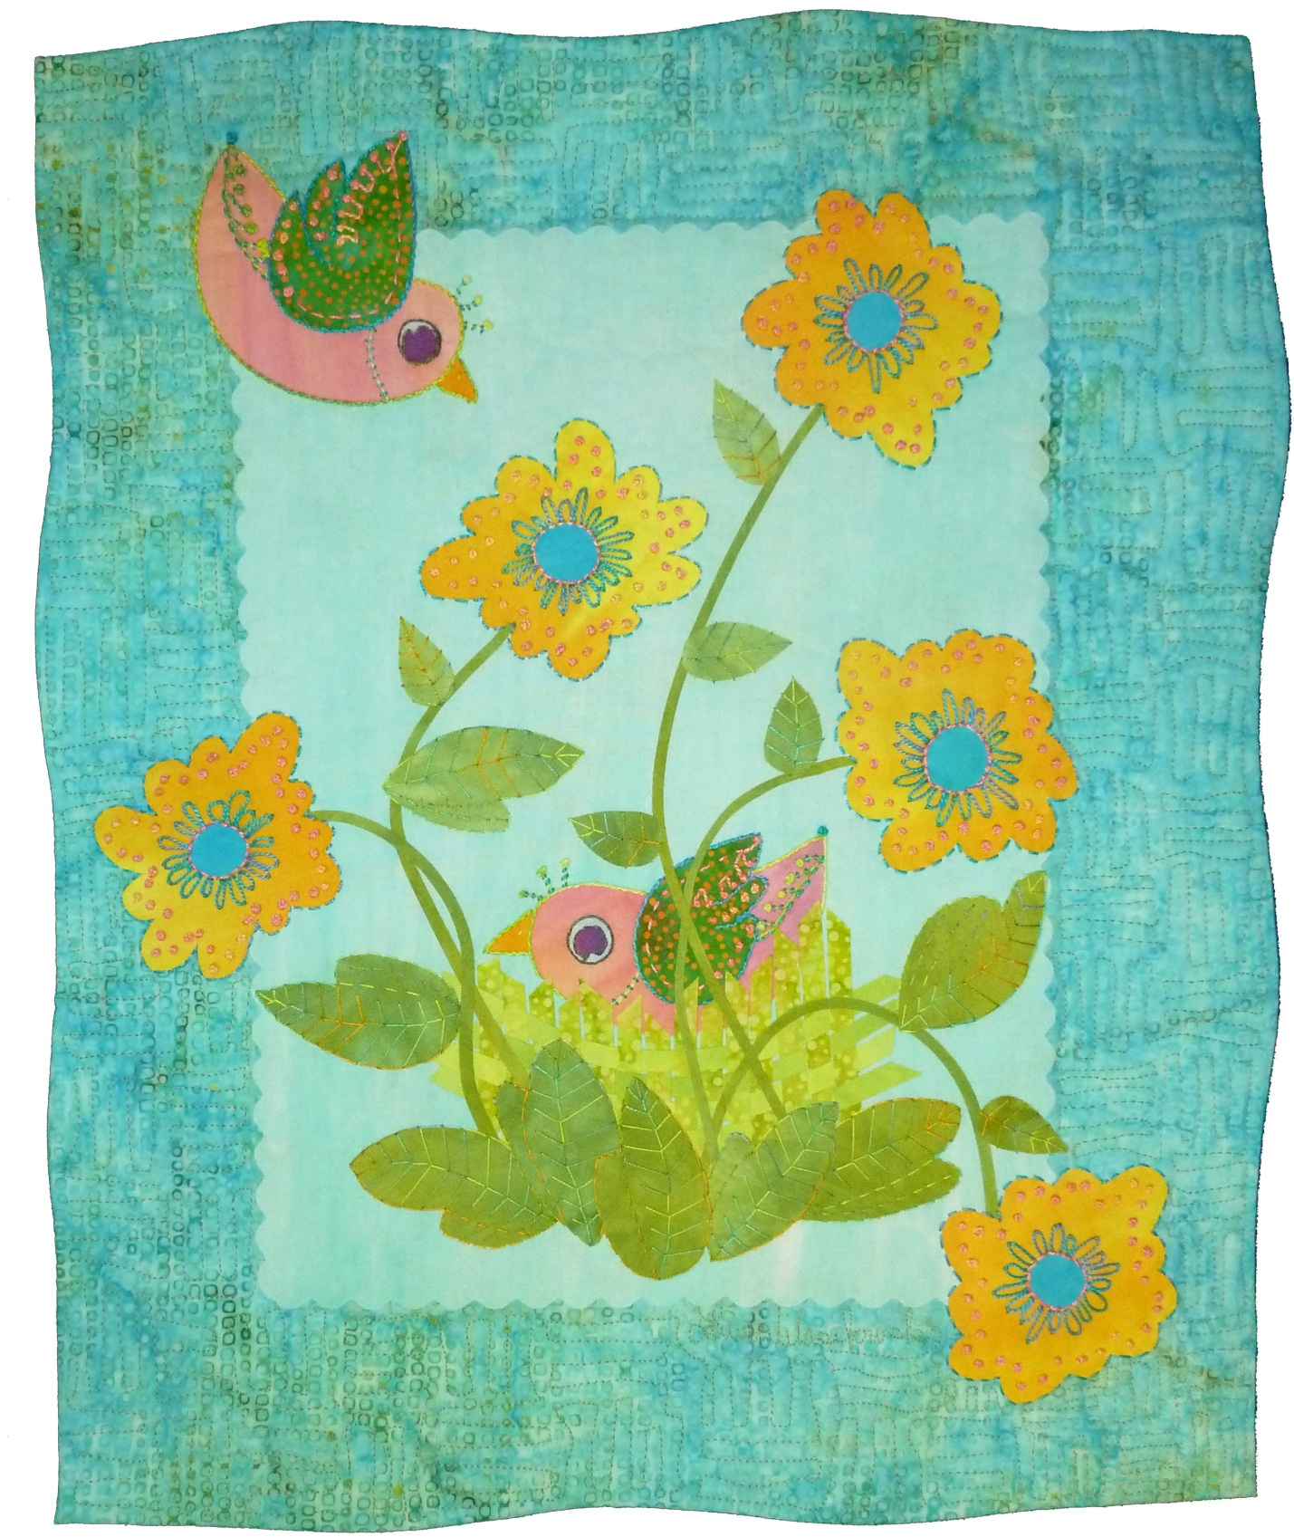
Birds and Flowers

A Fused Art Quilt, Finished Size about 14" x 17"
© Laura Wasilowski 2020

Birds and Flowers

A Fused Art Quilt, Finished Size about 14" x 17"
© Laura Wasilowski 2020

Materials and Tools

9" x 12" light blue for sky
16" x 19" blue background fabric
6" x 6" pink for birds
3" x 6" green for bird wings
2" x 2" yellow for bird beaks
2" x 2" pale blue for outer eye of bird
2" x 2" dark purple for inner eye of bird
6" x 6" medium green for nest
6" x 6" light green for nest
8" x 8" green for flower stems and leaves
3" x 15" yellow for flowers
1" x 6" blue for flower centers
2 yards of fusible web (Wonder Under recommended)
15" x 18" batting (Hobbs Heirloom Premium 80/20 Batting recommended)
15" x 18" Timtex stiff interfacing (for optional binding method)
14" x 17" backing fabric
Black Sharpie Fine Point marker or lead pencil
Parchment or baking paper (optional)
Teflon pressing sheet (optional)
Rotary cutter, mat, and ruler
Decorative rotary cutter blade like wave, pinking, or scallop
Size 8 or 12 embroidery thread
Size 4 or 5 embroidery needle
Machine quilting thread

Preparation
- Fuse all the fabrics following the manufacturer’s directions.
- After the fabric cools, remove all the paper except that on the background fabric.
- After the fabric cools, remove the release paper that comes with the fusible web and save it in 1 sheet. It will be needed for pattern transfer. (Parchment or baking paper may be used instead of release paper.)
- Note: Make sure you reserve 1" of fabric around each edge of your quilt top when designing your quilt if you are using the optional Wrapped Binding method below. This fabric wraps to the back of the quilt around the batting and Timtex to bind the quilt.

Directions
- Trim 1/4" from each edge of the sky fabric using a decorative blade in the rotary cutter.
- Center the sky vertically about 3" from the top of the background fabric. Fuse-tack into place.
- Place release paper on Bird A pattern. Trace the pattern with the Sharpie marker or a lead pencil.
- Place the marker side of the release paper onto the glue or fused side of the bird fabric. Fuse the paper in place for 5 seconds.
- After the fabric cools, remove the release paper from the fabric. The ink from the pattern will transfer to the glue.
- Cut out the bird shape just inside the black line with scissors.
- Repeat Steps 3 – 6 to make Bird B, the Bird A wing, Bird B wing, and 2 beaks or free-cut the beak shapes.
- Center Bird A about 3" up from the bottom edge of the sky. Slip the bird’s beak just under the front of the bird’s head. Fuse-tack into place.
- Place Bird B at an angle in the upper left corner of the sky and extending onto the background fabric. Slip the bird’s beak just under the front of the bird’s head. Fuse-tack into place.
- Place the Bird A wing on bird A and the Bird B wing on Bird B. Fuse-tack into place.
- Free-cut 2 dots measuring about 1/2" in diameter from the outer eye fabric. Free-cut 2 dots measuring about 1/4" in diameter from the inner eye fabric. Snip a little notch or triangle of fabric from each inner eye dot.
- Place the outer eye dot onto the Bird A’s head. Add the inner eye circle to make the eye. Fuse-tack into place.
- Repeat Step 12 to make the eye for Bird B.
- Cut the nest fabrics on the bias to form 2 triangles. (Note: to cut on the bias, cut from corner to corner of the square piece of fabric to form 2 triangles. The long edge of the triangle is the bias edge.)
- Cut 14 bias strips measuring about 1/4" wide from the bias edges of the medium green nest fabric.
- Cut 4 bias strips measuring about 1/4" wide from the light green nest fabric.
- Align the 14 medium green strips vertically and next to each other on the release paper. Fuse-tack 1/2" of the top edge of each strip onto the paper leaving the lower part of the strips free.
- Weave the 4 light green strips horizontally through the vertical strips, fuse-tacking each horizontal strip as it is woven. Try curving the horizontal strips as you weave to make a bowl shape to the nest. After the fabric cools remove the woven nest collage from the paper.
- Trim the vertical strips to form the bottom of the nest.
- Place the nest horizontally over the lower edge of Bird A. Fuse-tack into place.
- Cut the stems and leaves fabric on the bias to form 2 triangles with bias edges
- Cut 5 stem strips measuring about 1/8" wide from the long or bias side of the one of the triangles.
- Repeat Steps 3 – 6 to make 5 flowers, 5 flower centers, 8 big leaves, and 6 little leaves or free-cut the shapes.
- Place the 5 flowers and 5 flower centers on the quilt. Fuse-tack the flowers just at the center of the flower leaving the base of the flower free.
- Slip the end of a stem about 1/8" under the base of a flower. Fuse the stem and curve it with one hand while fusing with the other. Fuse it down to the lower edge of the nest. Clip to size.
- Repeat Step 25 for each stem.
- Place the large leaves and small leaves on the stems and at the base of the nest. Fuse-tack into place.

Finishing with a Wrapped Binding
- Stack the Timtex and batting with the scrim side of the batt touching the Timtex. Trim each edge of the Timtex and batt in a wavy motion with a rotary cutter. Cut curves in and out that measure about 1/4" – 1/2 " deep.
- Remove the release paper from the quilt top. Center the non-scrim side of the batting onto the back of the quilt top. There should be about 1" of fabric hanging over the edge of the batting on each side.
- Flip the batting and quilt top over holding everything in place and place on release paper.
- Steam set the quilt top to the batting for about 10 seconds in each spot.
- After it cools, remove it from the release paper.
- Add hand embroidery stitches with the size 8 or 12 pearl cotton thread and an embroidery needle.
- Place the quilt top right-side down on the ironing surface. Match the Timtex shape to the batting and put in place.
- At a corner, fold the quilt top fabric onto the Timtex to form a right angle. Leave a little ease at the tip of the corner to get a sharp point. Fuse-tack the fabric just at the corner.
- Repeat Step 8 at each corner of the quilt.
- At a corner, fold one side of the quilt top fabric onto the Timtex. Slowly pull, wrap, and fuse-tack the quilt top to the back following the edge of the Timtex. Stop about mid-way down the edge.
- At that same corner, fold the other side of the quilt top fabric onto the Timtex making a sharp point at the corner. Slowly pull, wrap, and fuse-tack the quilt top to the back following the edge of the Timtex. Stop about mid-way down the edge.
- Repeat Steps 10 – 11 around the perimeter of the quilt.
- Trim about 1/2" from the perimeter of the backing fabric using a decorative blade in the rotary cutter.
- Center the backing fabric, glue side down, onto the back of the quilt. Fuse-tack into place.
- Steam set the back of the quilt.
- Machine stitch the quilt.
- Add a hanging loop to the back of the quilt.

For more information about fusing, read Laura’s books from C&T Publishing:
Fusing Fun! Fuse and Tell Journal Quilts Fanciful Stitches, Colorful Quilts

For more information about hand embroidery, read Laura’s book from C&T Publishing:
Joyful Stitching: Transform Fabric with Improvisational Embroidery

For more about the fabrics used in this pattern visit:
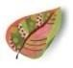Artfabrik www.artfabrik.com
laura@artfabrik.com
324 Vincent Place Elgin, IL 60123 847-494-9310

