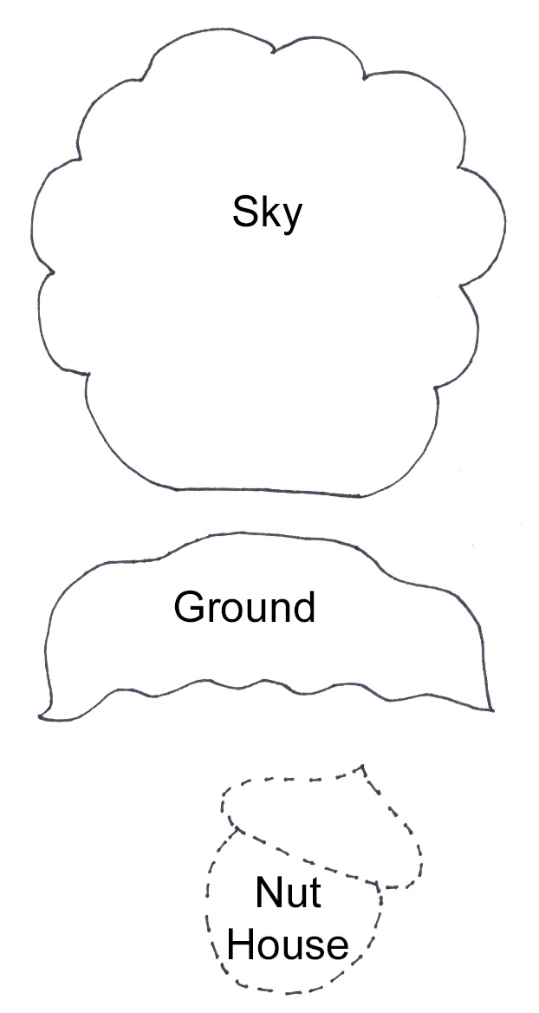
Frieda’s Nut House
Copyright Laura Wasilowski 2020
For step-by-step directions on how to stitch the Frieda’s Nut House embroidery, visit the Frieda’s Nut House Stitch-Along under the Tutorials Menu on www.artfabrik.com.
For more free-form embroidery ideas, see Laura Wasilowski’s book Joyful Stitching: Transform Fabric with Improvisational Embroidery (C&T Publishing, 2018)

How to Transfer Patterns for the Sky and Ground Fabric Shapes
1. Trace the patterns onto tracing paper using a black marker.
2. Pin the tracings onto the fabric color for that piece. Cut out the fabric shapes following the black line.

How to Transfer the Nut House Pattern to the Sky for Stitching
• Place tracing paper on the Nut House drawing and trace it with a black marker.
• Pin the tracing in place on the sky on the top edge of the ground after the ground is stitched into place.
• Select a sewing thread (40 or 50 weight) in a color contrasting to the sky fabric or use a contrasting embroidery thread. Use a sewing needle or size 5 embroidery needle.
• Follow the black marker lines on the tracing and stitch the outline of the shapes in the design using Running Stitches.
• After stitching the outline, remove the paper using the tip of a pin to score the paper next to the stitches. Gently rip away the paper.
• The Running Stitches define the edges of the design and will be removed after stitching the shapes with permanent stitches.

