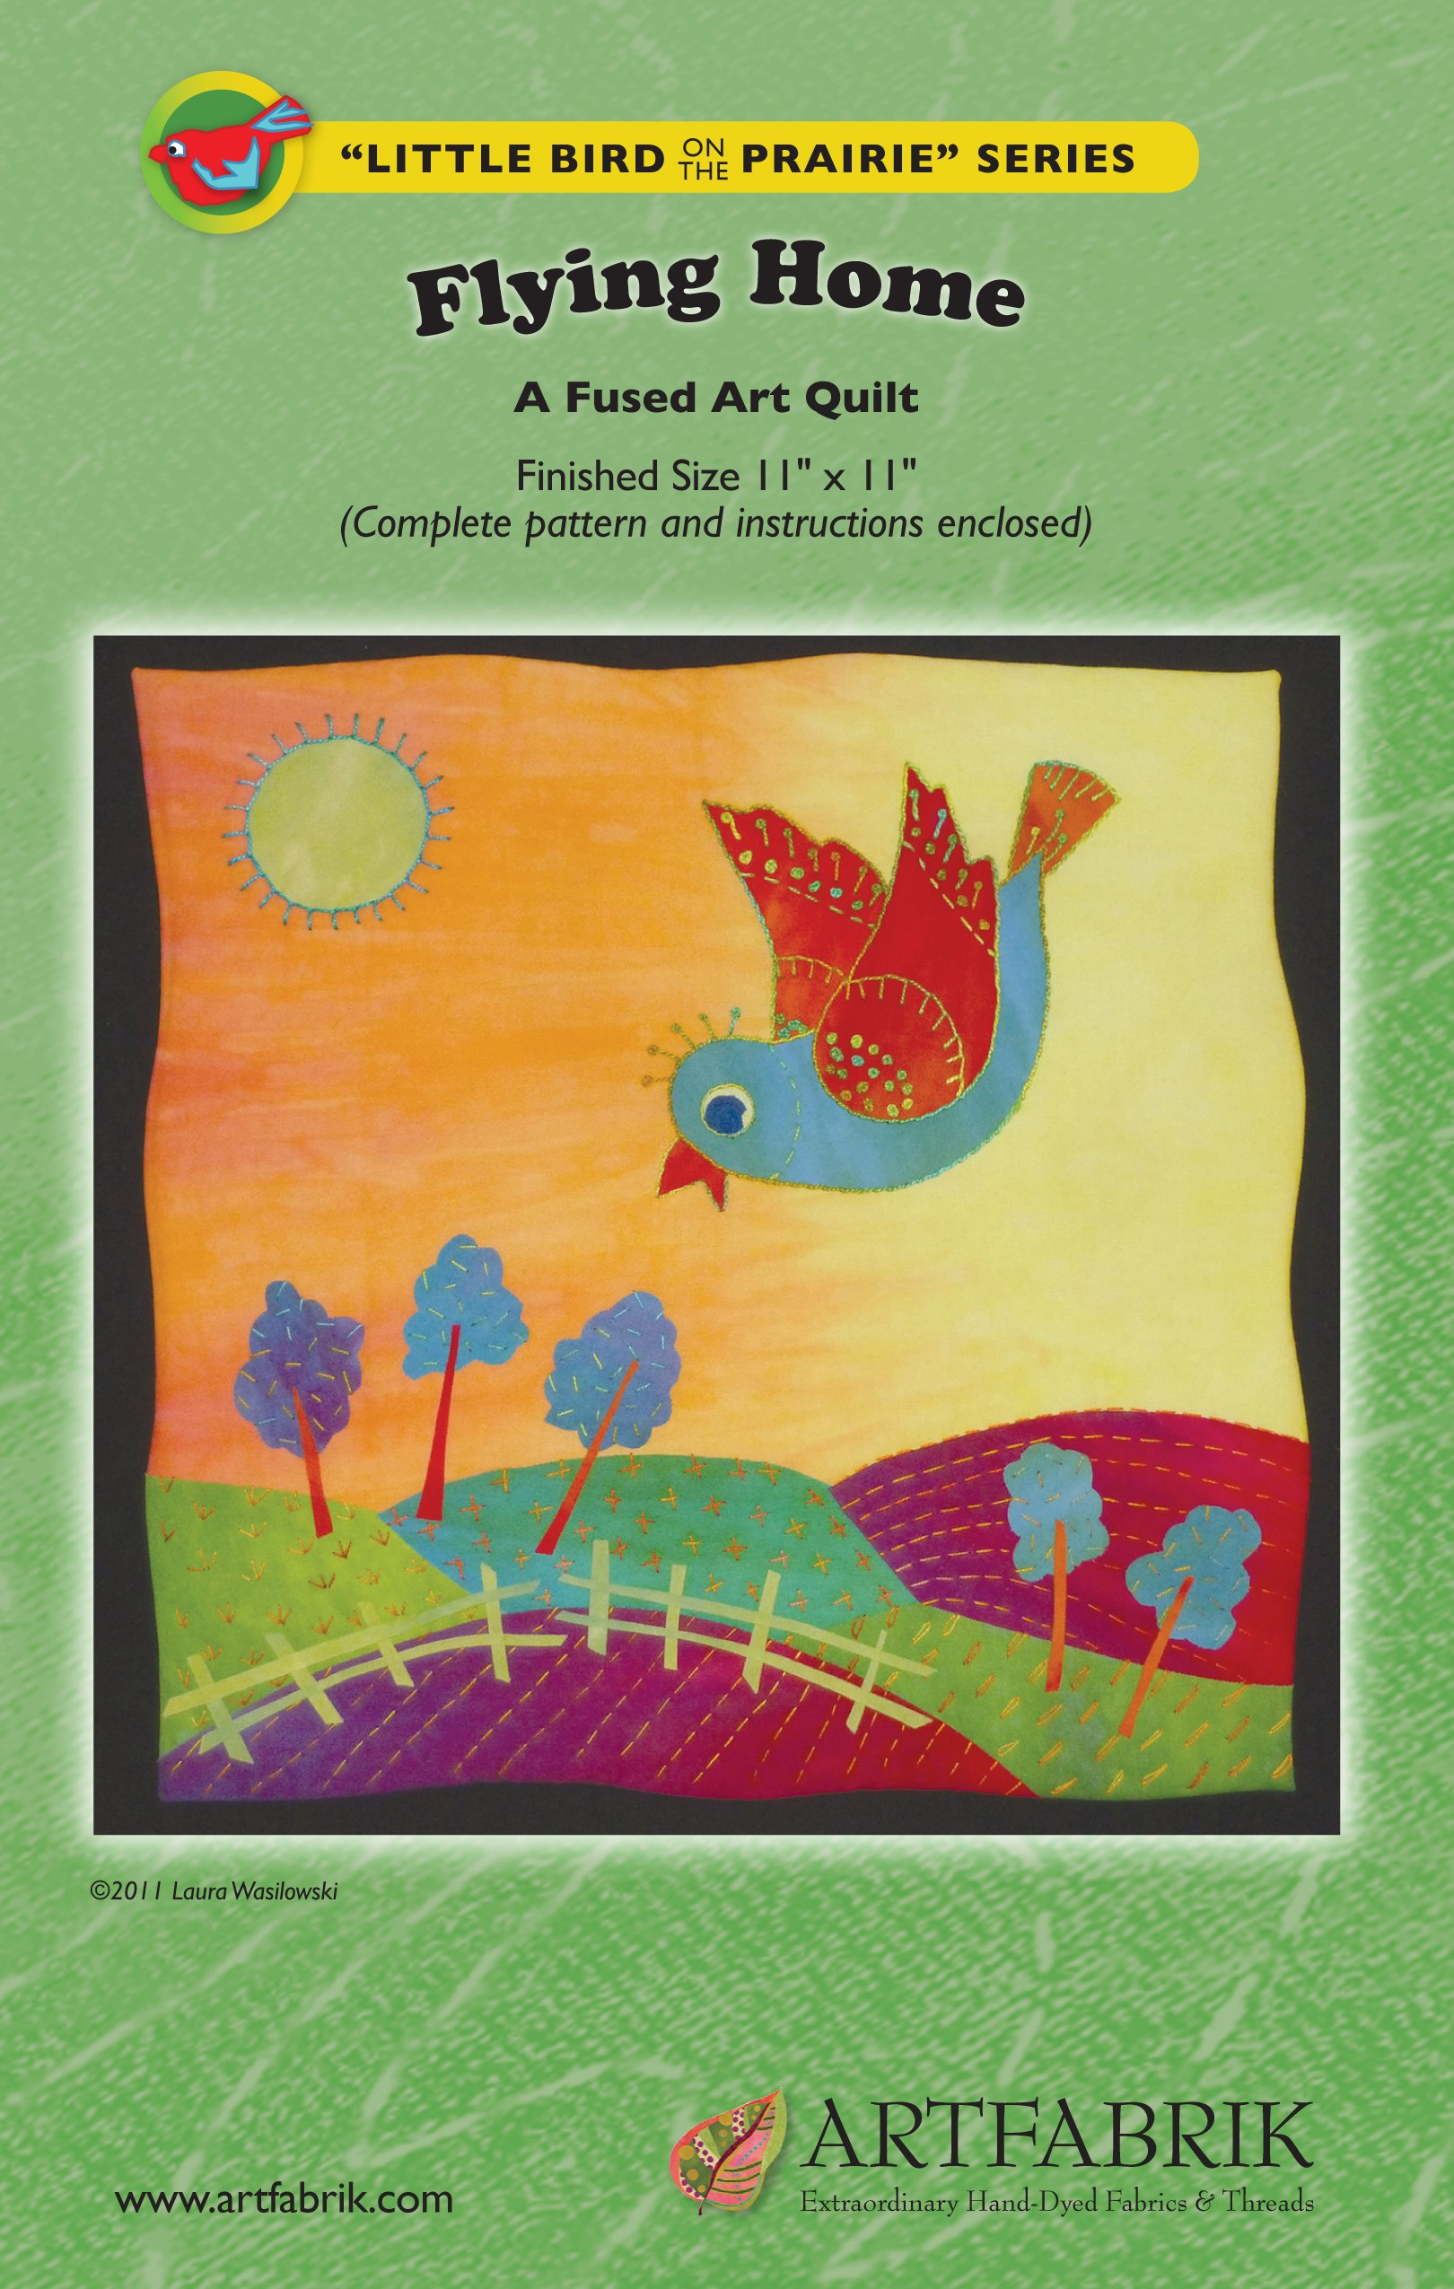

Flying Home
From the Little Bird on the Prairie Series A Fused Art Quilt, Finished Size 11" x 11"
© Laura Wasilowski 2020
Materials and Tools
12" x 9" light yellow to orange for Sky  8" x 8" medium green for Field A and Field D  3" x 7" dark green for Field B  8" x 10" red violet for Field C and Field E  6" x 9" blue for Bird Body and Trees  5" x 5" red for Right Wing, Left Wing, Tail, Beak  1" x 1" light yellow for Outer Eye  1" x 1" dark blue for Inner Eye  2" x 2" light green for Sun  4" x 4" orange for Tree Trunks  5" x 5" light green for Fence  12" x 12" backing fabric | 1 ½ yards of fusible web (Wonder Under #805 recommended)  12" x 12" batting  12" x 12" Timtex stiff interfacing (for optional binding method)  Black Sharpie Fine Point marker or lead pencil  Parchment (baking) paper (optional)  Rotary cutter, mat, and ruler  Pinking rotary cutter blade (optional)  Size 8 or 12 embroidery thread  Size 4 or 5 embroidery needle  Machine quilting thread

Preparation
- Fuse all the fabrics except the backing fabric. Follow the directions that come with the fusible web.
- After the fabric cools, remove the paper that comes with the fusible web in 1 sheet. This is called release paper. It will be needed for construction of quilt elements and for pattern transfer.
- Note: Make sure you reserve about 1" of fabric around the edge of the quilt top when designing your quilt if you are using the Wrapped Binding below. This fabric wraps to the back of the quilt around the batting and Timtex.

Directions
- Place the Sky fabric horizontally onto a large piece of release paper or parchment paper. Fuse-tack into place.
- Place release paper on the Field A pattern. Trace the pattern with the Sharpie marker or a lead pencil.
- Place the marker side of the release paper onto the glue or fused side of the Field A fabric. Fuse the paper in place for 5 seconds.
- After the fabric cools, carefully remove the release paper from the fabric. The ink from the tracing will transfer to the glue.
- Cut out the Field A shape just inside the black line with scissors.
- Repeat Steps 2 – 5 with the remaining Fields.
- Place Field A horizontally about 1/4" onto the left side of the bottom of the sky. Align the vertical left edge of Field A with the vertical edge of the sky.
- Overlap Field B about 1/4" onto the right side of Field A and the lower edge of the sky.
- Overlap Field C about 1/4" onto the right side of Field B and the lower edge of the sky.
- Overlap Field D about 1/4" onto the bottom edge of Fields C and B.
- Overlap Field E about 1/4" onto the bottom edge of Fields A, B, and left edge of D. Fuse-tack all the fields into place joining them to the sky.
- Repeat Steps 2 – 5 for the Bird Body, Right Wing, Left Wing, Tail, Beak, Outer Eye, Inner Eye, Sun, and 5 Trees.
- Place the Bird Body at an angle in the Sky. The head should be about 4 1/2" down from the top edge of the sky fabric and about 6 1/2" in from the right side of the sky fabric.
- Slip the Right Wing and Tail about 1/4" under the Bird Body. Add the Left Wing. Fuse-tack into place.
- Place the outer eye, inner eye, and beak on the bird. Fuse-tack into place.
- Place the Sun and 5 Trees on the quilt top. Fuse tack into place.
- Cut the Tree Trunk fabric on the bias to form 2 triangles. (Note: a bias-cut fabric is cut at a 45 degree angle from the grain of the fabric or from corner to corner on a square piece of fabric to form 2 triangles.)
- Cut 5 strips measuring about 1/8" wide by 2" long from the long or bias side the triangles.
- Place a Tree Trunk on each Tree. Fuse-tack into place.
- Cut the Fence fabric on the bias to form 2 triangles.
- Cut 4 strips measuring about 1/8" wide and about 4" long from the bias side of one of the triangles to form the 4 fence rails.
- Cut 8 strips measuring about 1/8" wide and 1" long from the bias side of the other triangle to form the fence posts.
- Place the fence posts vertically across Field E.
- Place the fence rails horizontally on the fence posts. Form 2 rows of rails to join the posts. Fuse-tack into place.
- Finish the quilt with the following Wrapped Binding or follow Steps 1 – 5 below and use another binding method of your choice.

Finishing with a Wrapped Binding (Optional)
- Remove the release paper from the quilt top. Center the non-scrim side of the batting onto the back of the quilt top. (Please note that if the background fabric is applied to the scrim side of the batting and fused into place, the quilt may appear rippled.) There should be about 1" of fabric hanging over the edge of the batting on each side.
- Flip the batting and quilt top over holding everything in place and place it back onto the release paper.
- Place a dry cloth on the quilt top and steam set the top to the batting for about 10 seconds in each spot.
- After it cools, remove it from the release paper.
- Add hand embroidery stitches with the size 8 or 12 pearl cotton thread and an embroidery needle.
- Place the quilt top right-side down on the ironing surface. Match the Timtex shape to the batting and put in place.
- At a corner, fold the quilt top fabric onto the Timtex to form a right angle. Leave a little ease at the tip of the corner to get a sharp point. Fuse-tack the fabric just at the corner.
- Repeat Step 7 at each corner of the quilt.
- At a corner, fold one side of the quilt top fabric onto the Timtex. Slowly pull, wrap, and fuse-tack the quilt top to the back following the edge of the Timtex. Stop about mid-way down the edge.
- At that same corner, fold the other side of the quilt top fabric onto the Timtex making a sharp point at the corner. Slowly pull, wrap, and fuse-tack the quilt top to the back following the edge of the Timtex. Stop about mid-way down the edge.
- Repeat Steps 9 – 10 around the perimeter of the quilt.
- Trim about 1/2" from the perimeter of the backing fabric. Use a decorative blade in the rotary cutter if available.
- Center the backing fabric, glue side down, onto the back of the quilt. Fuse-tack into place.
- Steam set the back of the quilt.
- Machine stitch the quilt.
- Add a hanging loop to the back of the quilt.

For more information about fusing, read Laura’s books from C&T Publishing:
Fusing Fun! Fuse and Tell Journal Quilts Fanciful Stitches, Colorful Quilts

For more about the fabrics used in this pattern visit:
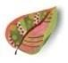Artfabrik www.artfabrik.com
laura@artfabrik.com
324 Vincent Place Elgin, IL 60123 847-494-9310
Sun
Right Wing
Tail
Left Wing
Beak
Inner Eye
(cut 2)
Outer Eye
(cut 2)
Bird Body
Tree
(
cut
5)
Field A
Field B
Field C
Field D
Flying Home
A Fused Art Quilt, Finished Size 11" x 11"
© Laura Wasilowski 2011
Field E

