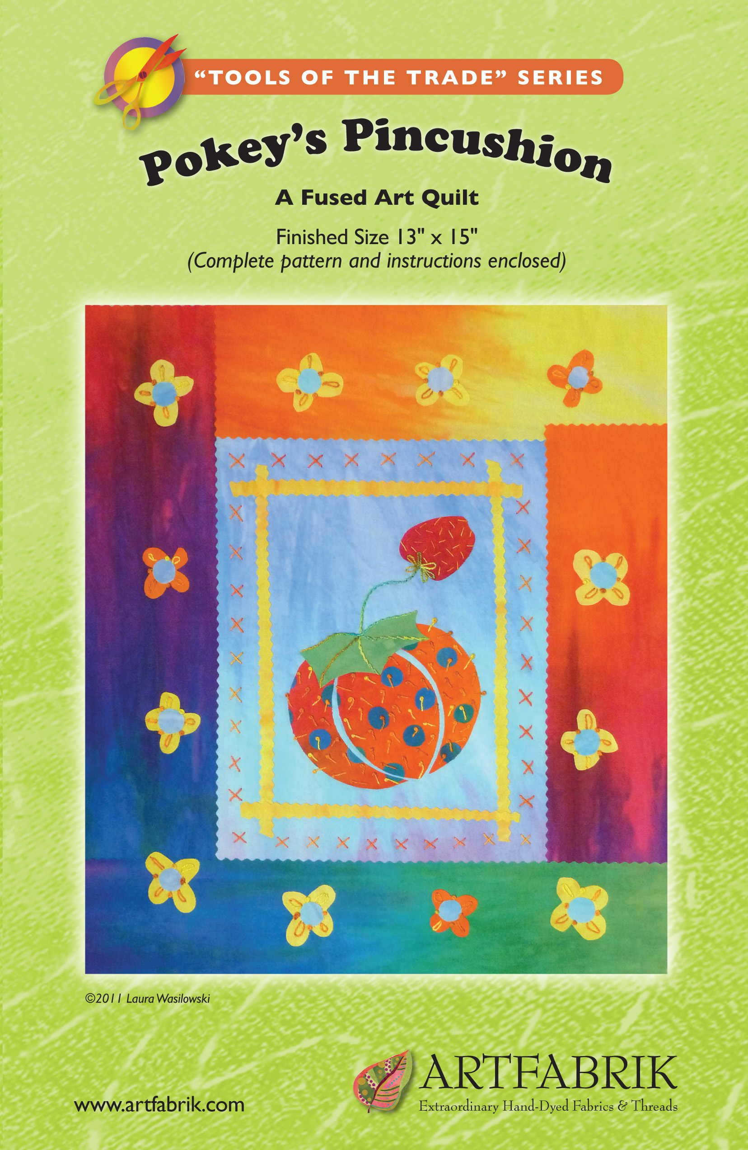

Pokey’s Pincushion
Tools of the Trade Series
A Fused Art Quilt, Finished Size 13" x 15"
© Laura Wasilowski 2019

Materials and Tools

- Background fabric: 8" x 10" of light blue
- Pincushion dot fabric: 2" x 9" of blue
- Pincushion fabric: 6" x 6" of red/orange
- Strawberry fabric: 2" x 2" of red
- Pincushion top fabric: 2" x 4" of green
- Flower fabric: 6" x 8" of yellow/orange
- Flower center fabric: 1" x 7" of blue
- Framing strips fabric: 1 1/2" x 8" of yellow
- Top & Bottom border fabric: 6" x 8" of bright colors
- Side border fabric: 6" x 15" of bright colors
- Binding fabric: 6" x 15" of light colors
- 2 yards fusible web (Wonder Under regular weight recommended)
- Parchment paper (optional)
- 13" x 15" backing fabric
- 13" x 15" batting
- Black Sharpie Fine Point marker or lead pencil
- Rotary cutter, mat, and ruler
- Pinking decorative rotary cutter blade
- Size 8 thread for hand stitching
- Size 3 hand embroidery needle
- Thread for machine quilting (optional)

Directions
- Fuse all the fabrics (except backing fabric). Follow directions that come with the fusible web.
- After the fabric cools, carefully remove the release paper that comes with the fusible web. Remove it in one sheet. Save the release paper for pattern transfer (Steps 6– 9) below.
- Center the background fabric vertically onto the batting. Fuse-tack into place.
- Free-cut 18 dots measuring about 1/2" across from the pincushion dot fabric.
- Place the pincushion fabric onto release paper or parchment paper. Arrange the dots from Step 4 onto the pincushion fabric to make a polka-dot collage. Fuse-tack into place. After the fabric cools remove it from the paper.
- Place release paper onto the pincushion pattern. Trace each of the 3 shapes with the marker.
- Place the marker side of the paper onto the glue or fused side of the pincushion fabric. Fuse the paper in place for 5 seconds. Let the fabric cool.
- Remove the release paper from the fabric. The ink will transfer to the glue.
- Cut out the 3 shapes just inside the black lines.
- Center the pincushion parts onto the background fabric. Place them about 2" up from the bottom of the background fabric. Separate the pincushion parts by about 1/16" to help define the shape. Fuse-tack into place.
- Repeat Steps 6 – 9 to make the strawberry and pincushion top.
- Place the strawberry onto the background fabric. Fuse-tack into place.
- Place the pincushion top onto the top of the pincushion. Fuse-tack into place.
- Cut out 4 fabric strips measuring 1/4" x 8" from the framing strips fabric with a pinking blade.
- Arrange the strips evenly around the pincushion. Snip to size. Fuse-tack into place.
- Repeat Steps 6 – 9 to make 12 flowers and 12 flower dots or free-cut the shapes without using the pattern. Keep the flowers for Step 7 below.

Border Directions
- Cut 2 borders strips measuring 3" x 8" for the top and bottom of the quilt with a pinking blade.
- Center and overlap the one of the border strips about 1/4" onto the top of the quilt. Fuse-tack into place.
- Repeat Step 2 on the bottom side of the quilt.
- Cut 2 borders strips measuring 3" x 15" for the sides of the quilt with a pinking blade.
- Center and overlap 1 of the side border strips about 1/4" onto the side of the quilt. Fuse-tack into place.
- Repeat Step 5 on the other side of the quilt.
- Add the flowers and flower dots around the border. Fuse-tack into place.

Fused Binding Directions
- Steam set the quilt top to the batting for 10 seconds using a dry pressing cloth to set the glue.
- Hand embroider the quilt just through the batting layer.
- Add the backing fabric and machine stitch the quilt through all layers if desired.
- Trim the quilt square with a ruler and rotary cutter and add a rod pocket if necessary.
- Cut 4 binding strips measuring about 1 1/4" with a pinking blade. Cut 2 strips the length of the quilt for the sides. Cut 2 strips the width of the quilt plus 2" for the top and bottom binding.
- Place the quilt right side up on the release paper and overlap the side binding about 1/2" on top of the side of the quilt. Fuse-tack into place. After the fabric cools, remove the quilt from the paper and fold the binding onto the back of the quilt. Fuse-tack into place.
- Repeat Step 6 for the other side of the quilt.
- Place the quilt right side up on the release paper and center the top binding strip across the top edge of the quilt. (There will be a 1" flap extending from each end of the quilt.) Overlap the binding about 1/2" onto the top edge. Fuse-tack into place.
- After the fabric cools, remove the quilt from the release paper and cut off 1/2" triangles from the top outside corners of the binding flaps.
- With the wrong side of the quilt facing up, fold the 2 side flaps of the top binding strip in toward the quilt. Align the fold with the edge of the quilt. Fuse-tack into place.
- At each corner fold the binding down to the top edge of the quilt to form a 45 angle (as if wrapping a package).
- Fold the binding down on the back of the quilt making a crisp corner. Fuse-tack into place.
- Repeat Steps 8 – 12 for the bottom binding.
- Steam set the binding on both sides. Stitch the binding by machine or by hand.

For more information about fusing, read Laura’s books from C&T Publishing:
Fusing Fun! Fuse and Tell Journal Quilts Fanciful Stitches, Colorful Quilts

For more information about hand embroidery read Laura’s book from C&T Publishing:
Joyful Stitching: Transform Fabric with Improvisational Embroidery

For more about the fabrics used in this pattern visit:
www.artfabrik.com laura@artfabrik.com
324 Vincent Place Elgin, IL 60123



